Home page 1
Trusted HVAC Experts in Virginia – Reliable Heating & Cooling Solutions

At Eco Smart HVAC Solutions, we provide dependable, cost-effective HVAC services tailored to meet your comfort needs across Virginia. From fast and efficient repairs to complete air conditioning installations and heating system maintenance, our experienced and certified technicians are committed to delivering high-quality results every time.
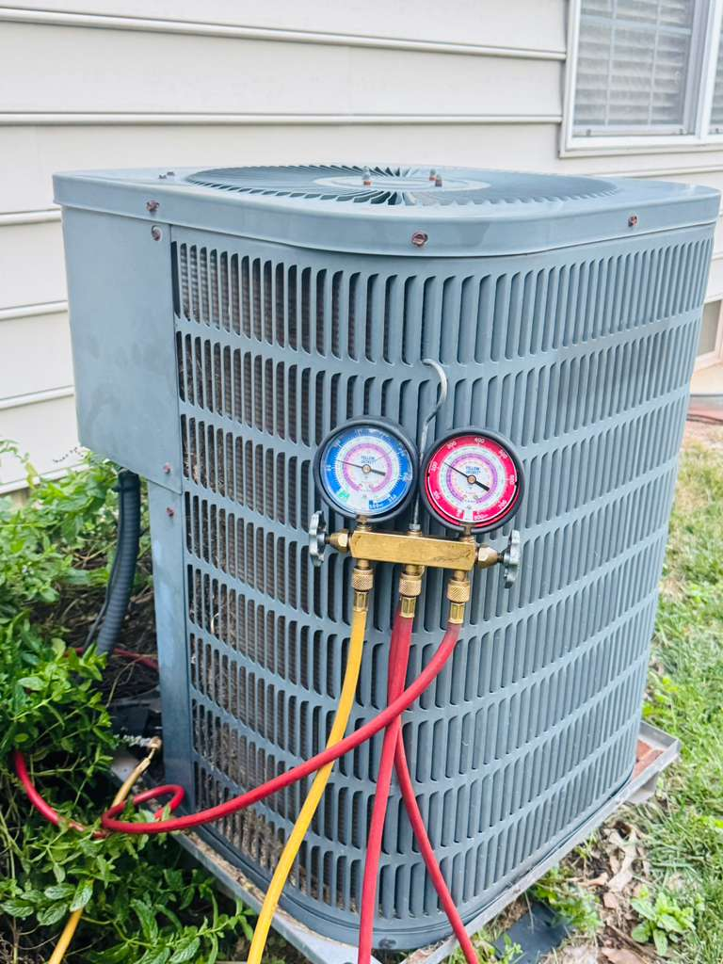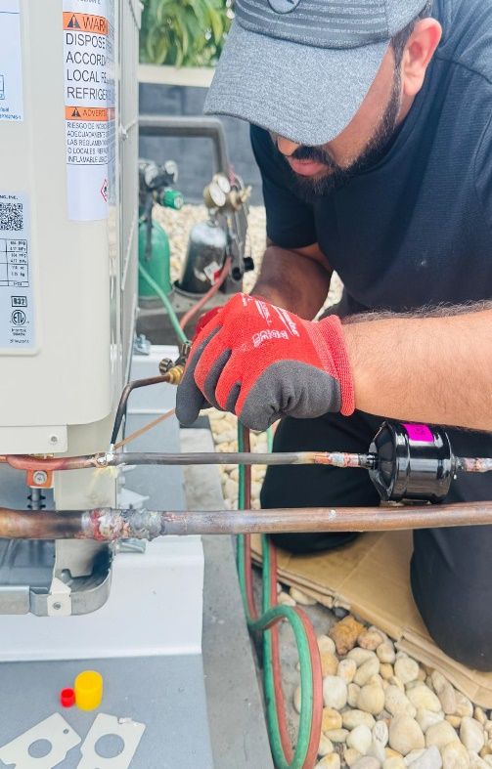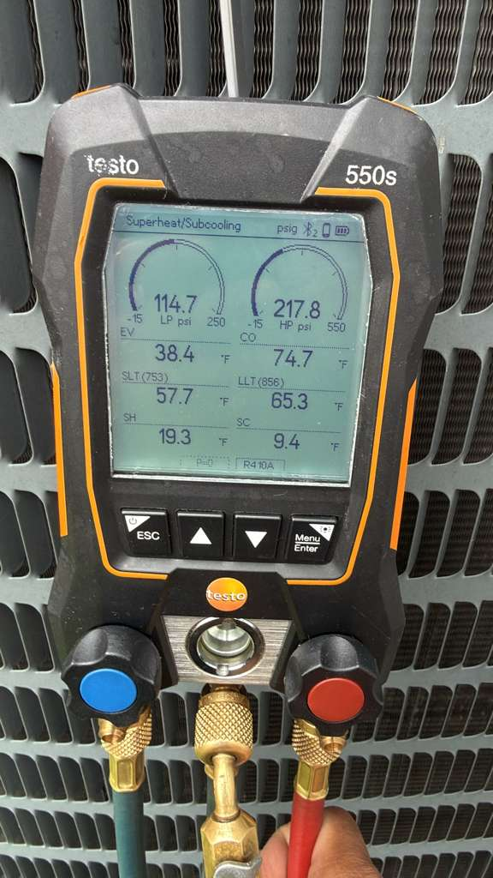

Whether you're facing a sudden AC breakdown or planning a full HVAC system upgrade, we offer energy-efficient solutions that ensure year-round comfort—keeping your home or business cool in the summer and warm during the winter months.

Get in touch today for expert HVAC services that prioritize your comfort, efficiency, and peace of mind.

Our HVAC Services Page 2
Complete HVAC Services You Can Trust – Reliable, Efficient & Available When You Need Them Most
Eco Smart HVAC Solutions LLC – Your Trusted Partner for Residential and Commercial HVAC Solutions
Installation & System Replacement
Whether you’re building a new space or upgrading an outdated system, we offer expert HVAC installation services. From air conditioning units to complete heating systems and smart HVAC integrations, we ensure your system is installed for maximum performance and efficiency.
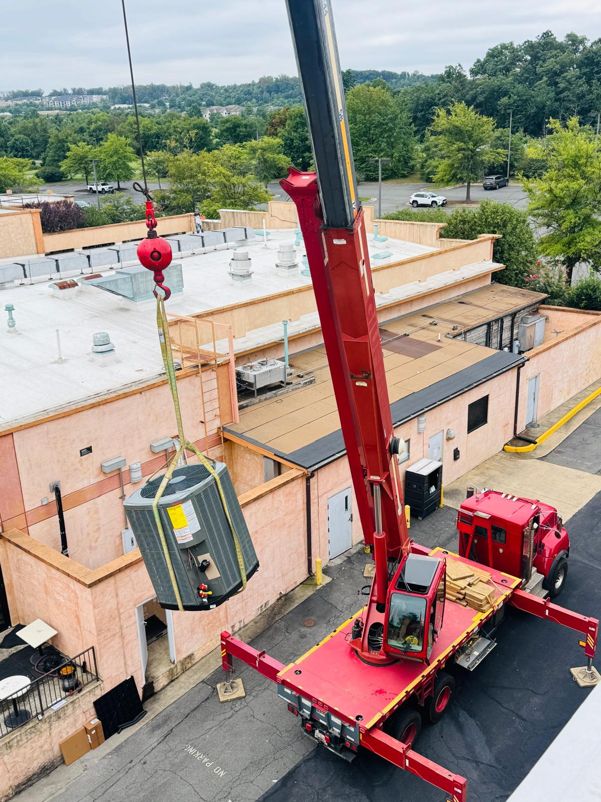
HVAC Repair & Troubleshooting
Experiencing issues with your heating or cooling system? Our team quickly diagnoses and resolves problems to restore comfort. We handle everything from minor repairs to complex system faults.
• Emergency HVAC repairs (24/7 support)
- AC repair & inspection
- Complete system diagnostics and troubleshooting

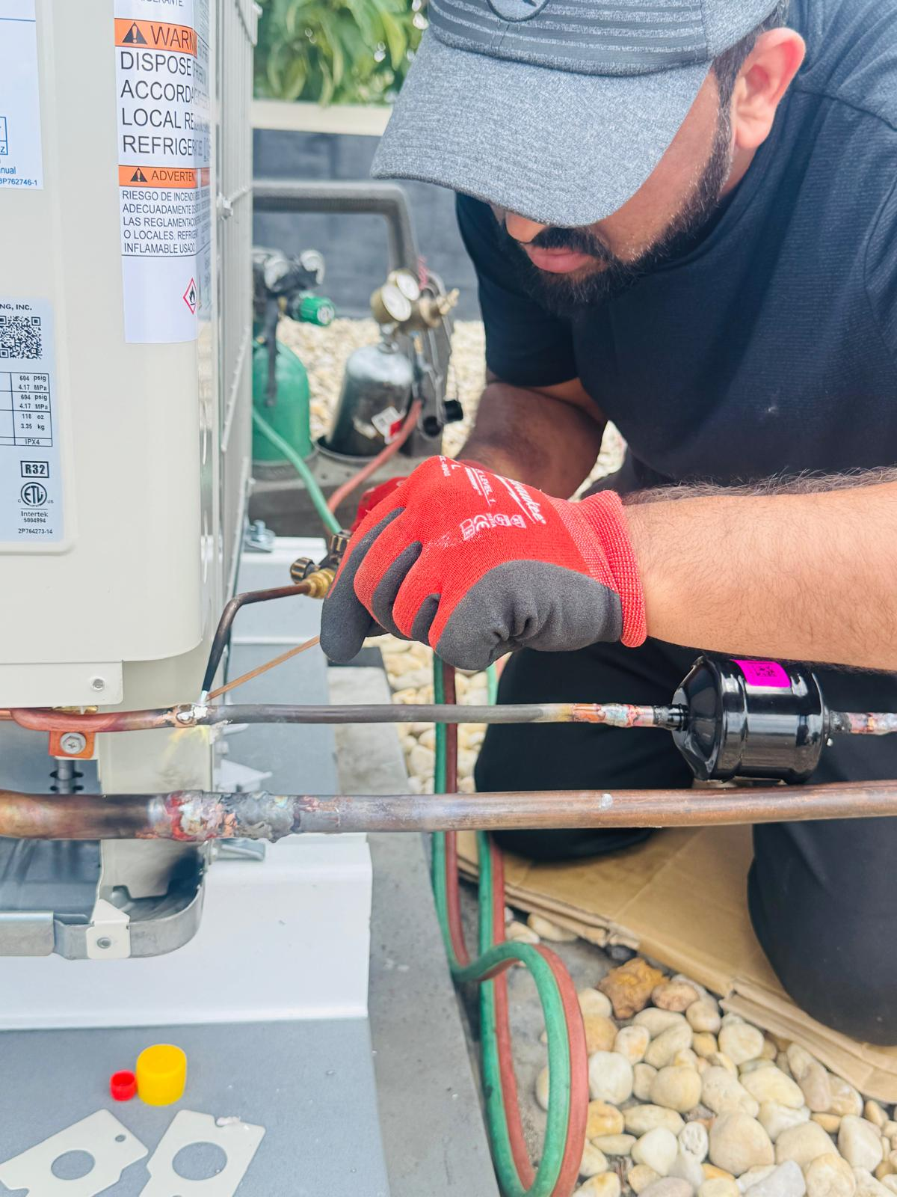
- 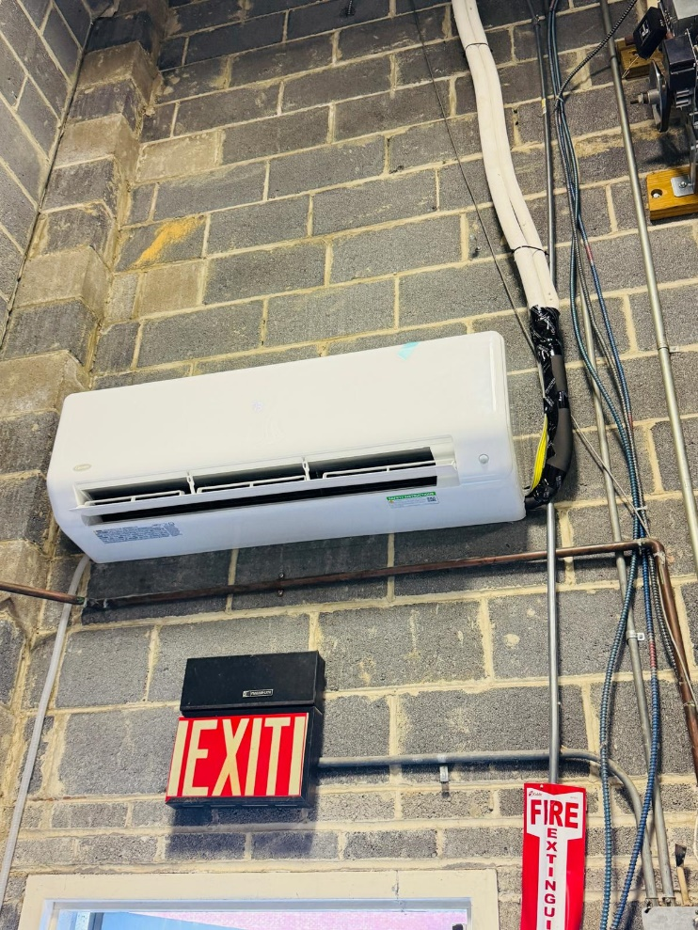
Maintenance & System Inspections
Regular maintenance is key to extending the life of your HVAC system. We provide thorough inspections, routine servicing, and preventive maintenance plans to keep your system running efficiently and reduce the risk of unexpected breakdowns.
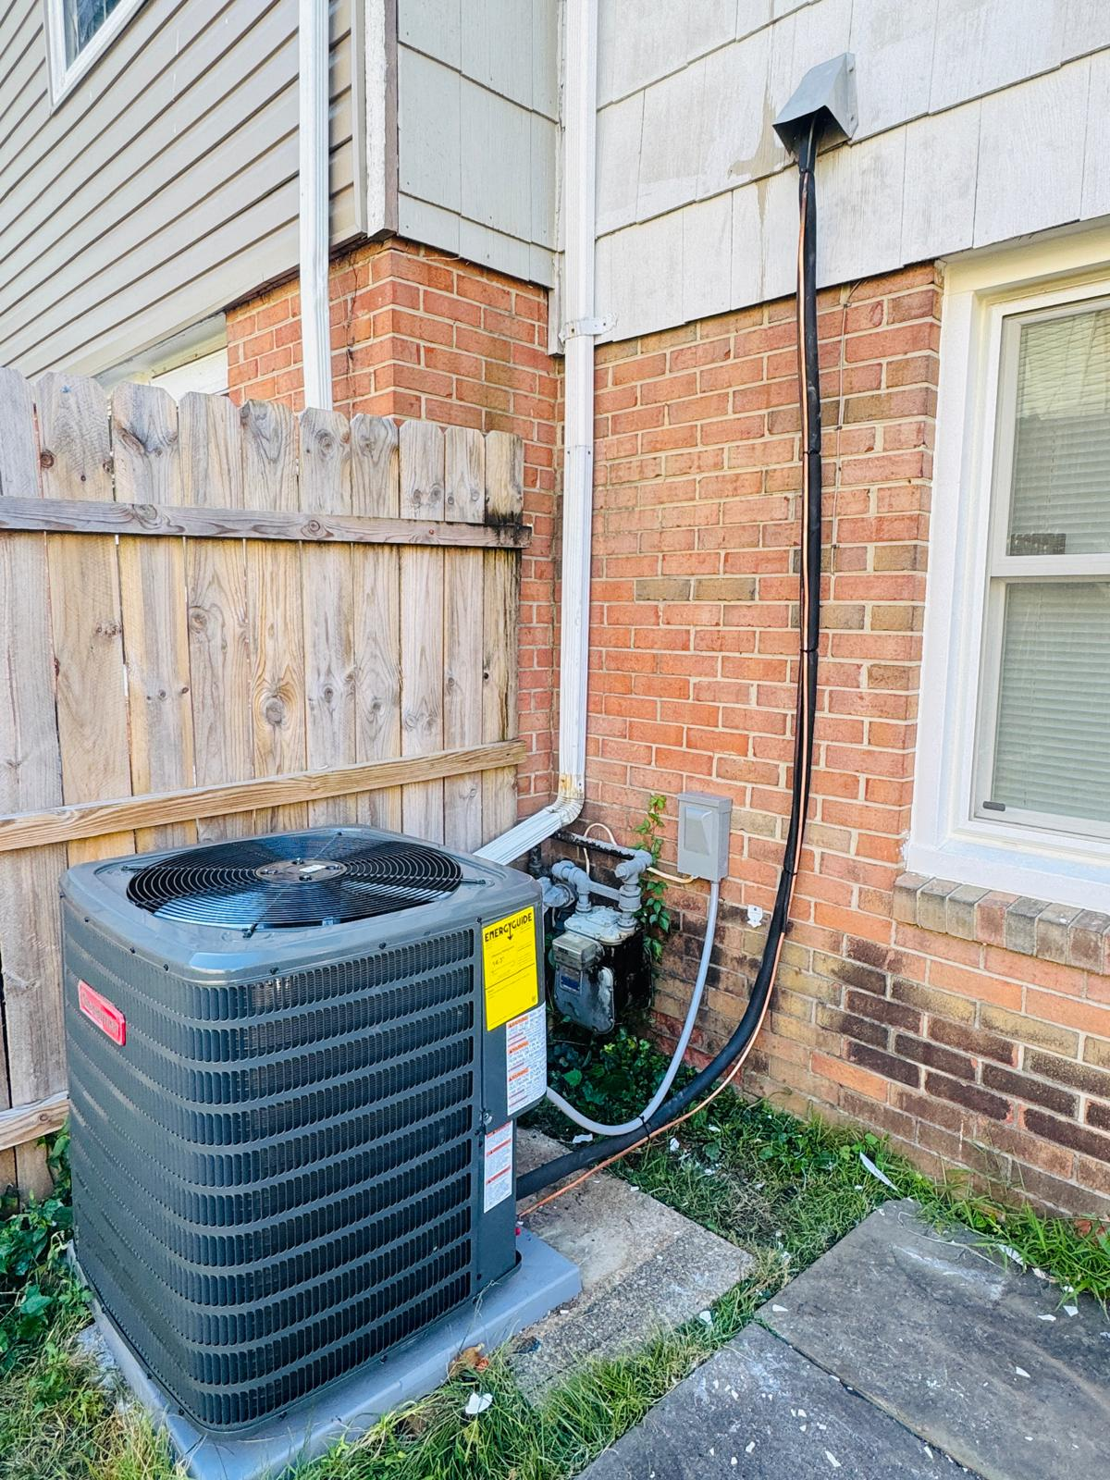
Ventilation & Indoor Air Quality
Breathe cleaner, healthier air with our ventilation and air quality services. We offer solutions to improve airflow and indoor comfort.
- Ductwork installation and repair
- Ventilation system services
- Indoor air quality testing
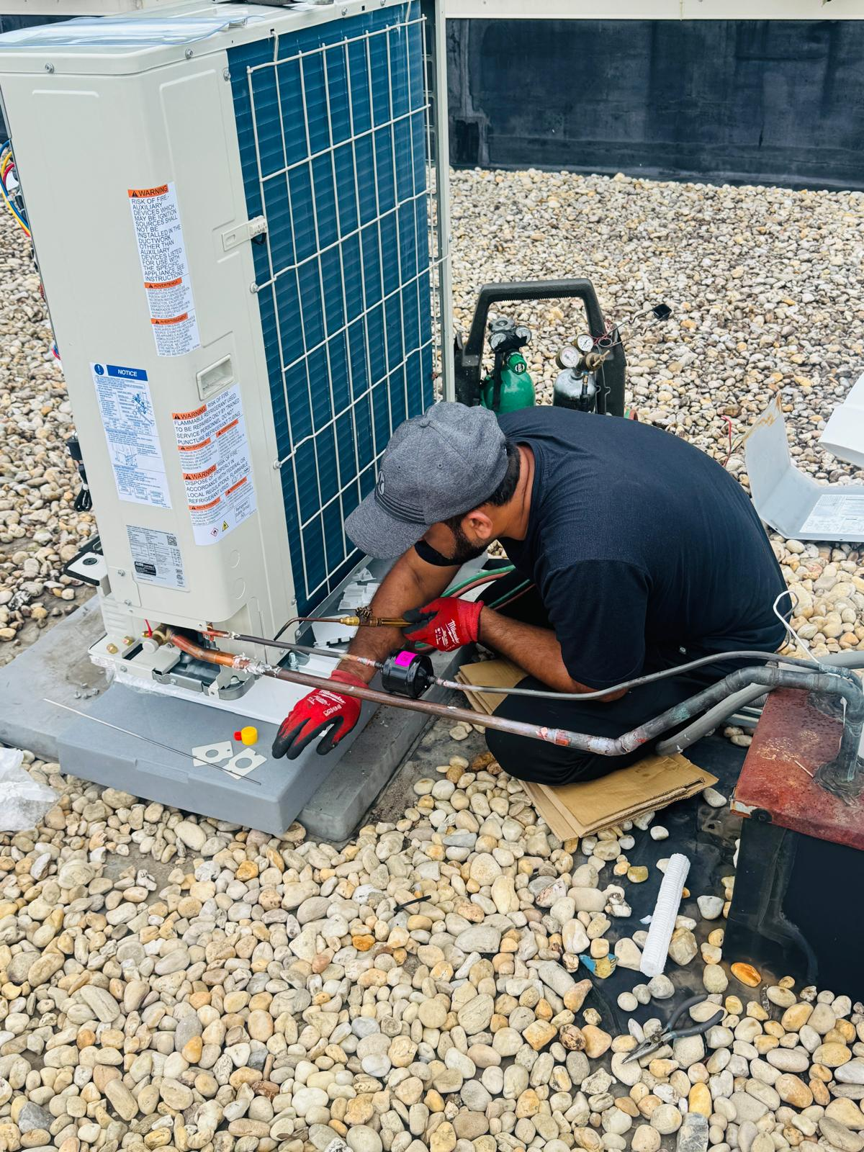
Upgrades & Energy Efficiency Solutions
Looking to reduce energy costs? We specialize in system upgrades, thermostat installation, and energy-efficient solutions that enhance performance while lowering your utility bills.
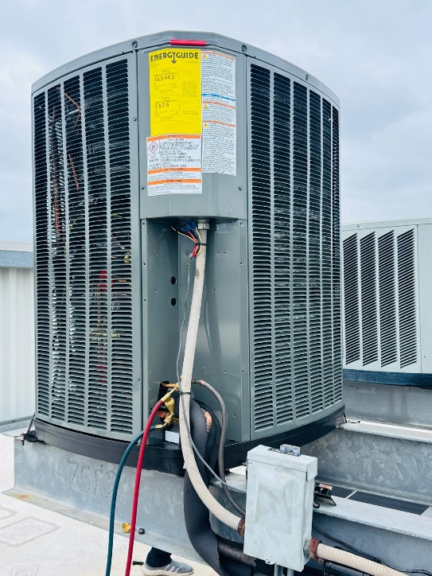
CONTACT US page

Get in Touch with Eco Smart HVAC Solutions LLC – Your Trusted HVAC Experts in Virginia
Need Fast, Reliable HVAC Service? We’re Here to Help.

Whether you need emergency HVAC repair, a free quote for a new system, or have questions about our services, the team at Eco Smart HVAC Solutions LLC is ready to assist. We are dedicated to providing prompt, professional service to ensure your comfort all year round.

Let's Get In Touch
Contact us today to schedule an appointment or learn more about our services. Experience the difference with Eco Smart HVAC Solutions LLC – where quality meets reliability.
Areas We Serve
( Add google map)
We proudly serve residential and commercial clients across Virginia, delivering dependable HVAC solutions wherever you need us.

Phone :703-832-6339
Address :11090 wainwright Pl Manassas
20109 VA
Mail: Ecosmarthvacsolutions@gmail.com

